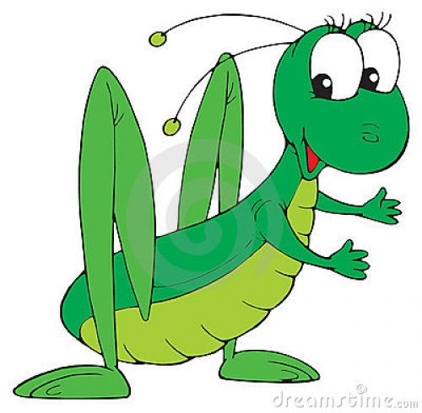 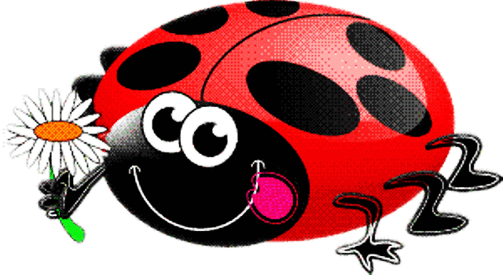

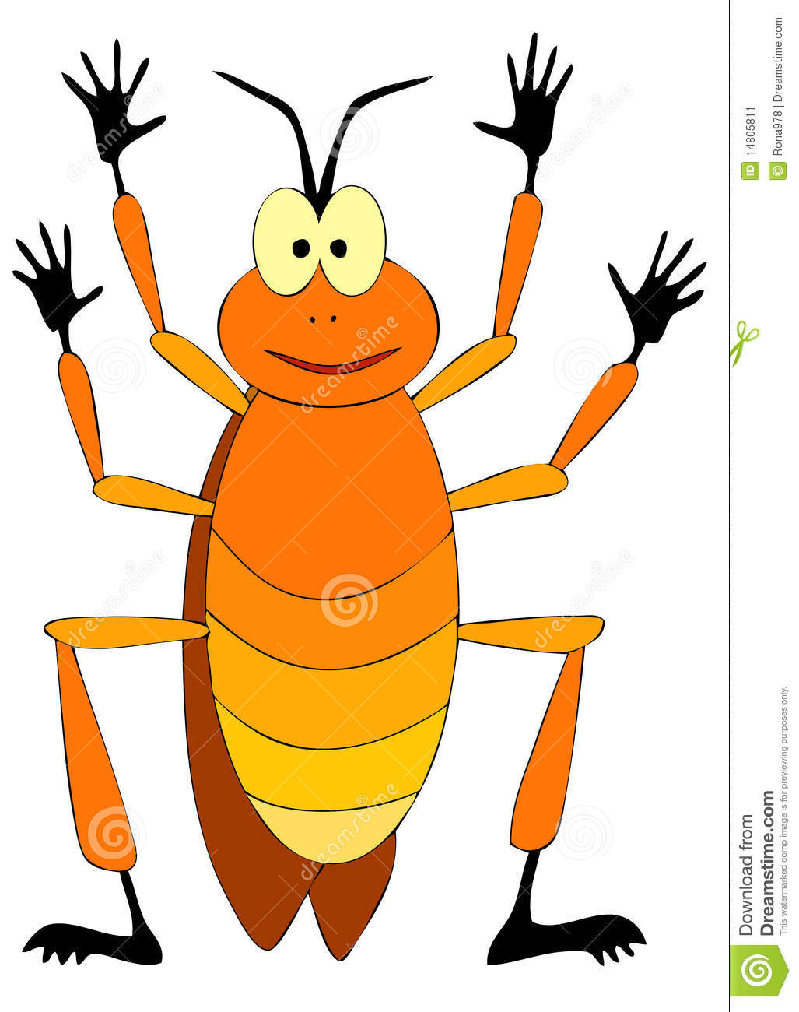

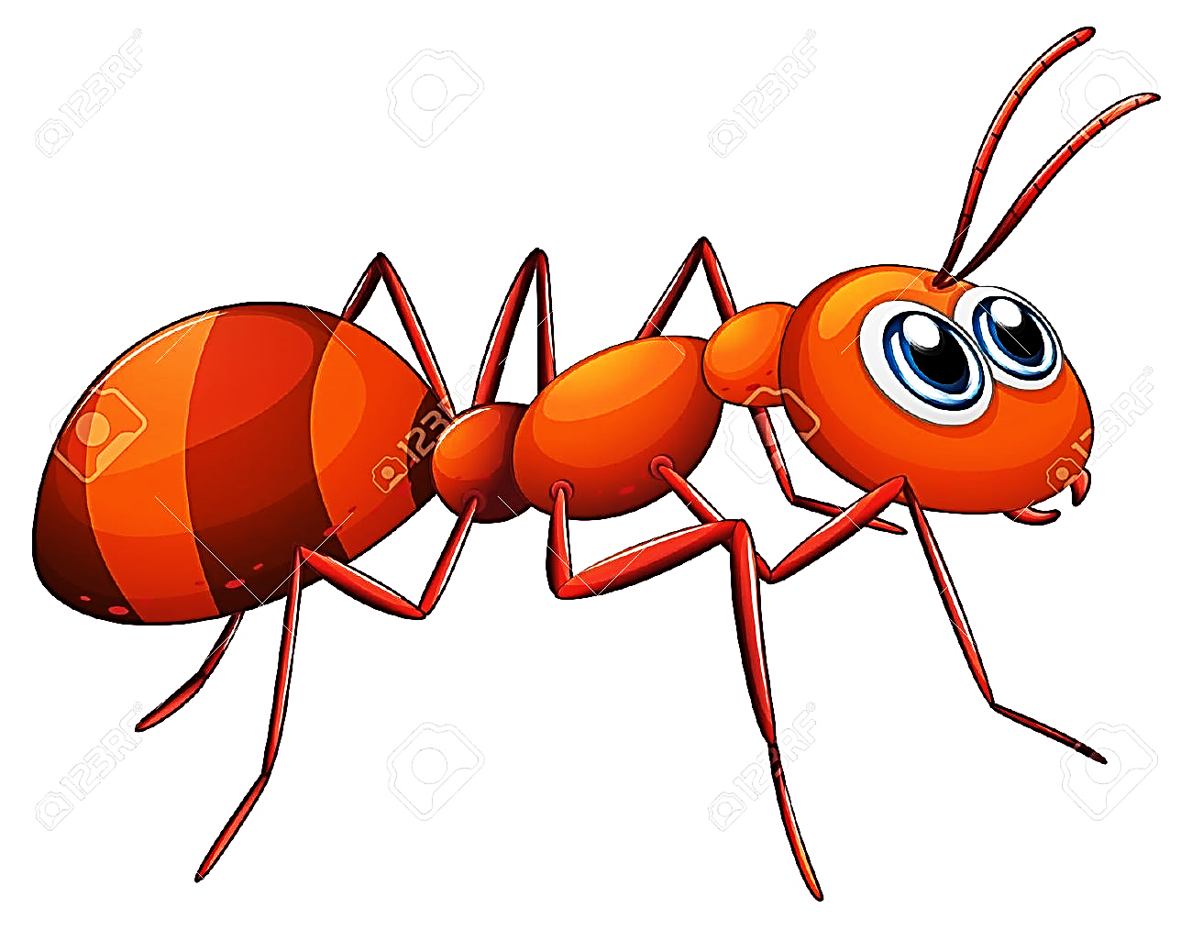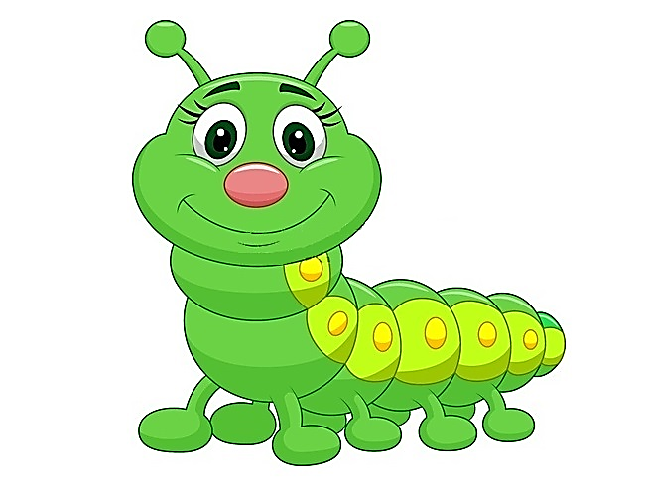

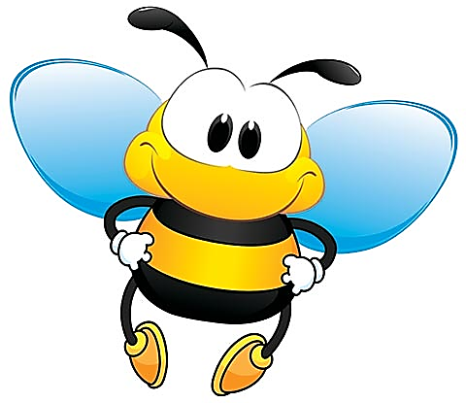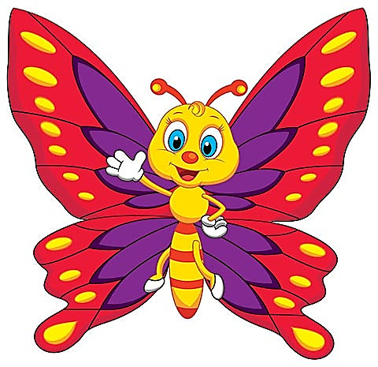

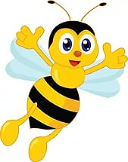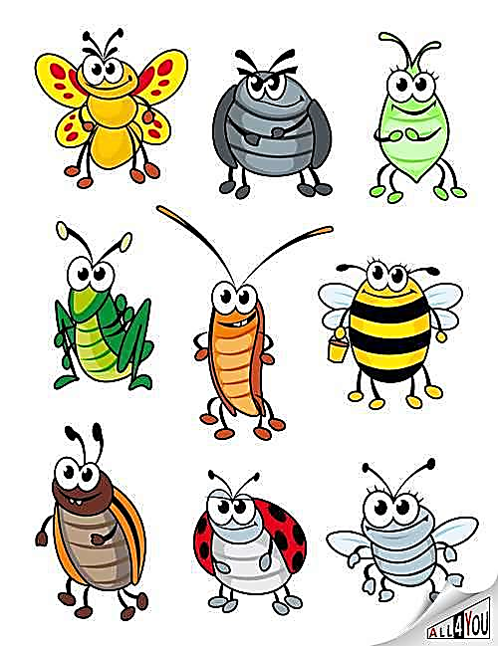

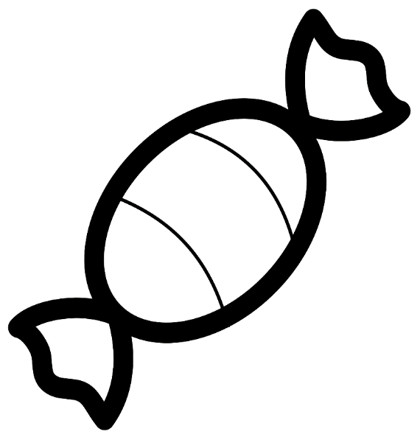



|  |  |  |  |
| --- | --- | --- | --- |
| **Ц** | **О** | **К** | **О** |
| **Т** | **У** | **Х** | **А** |

|  |  |  |  |
| --- | --- | --- | --- |
| **41** | **32** | **23** | **18** |
| **90** | **64** | **50** | **45** |

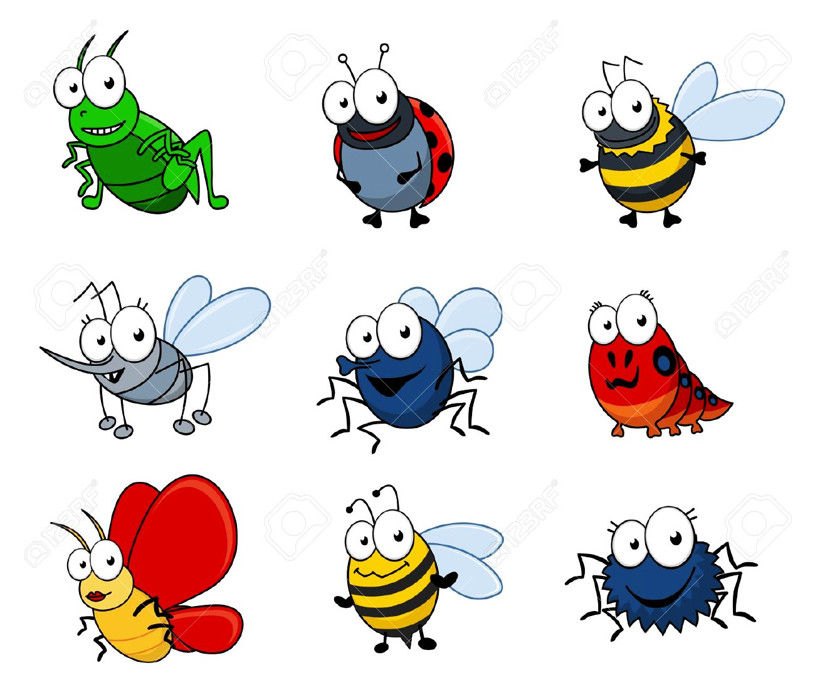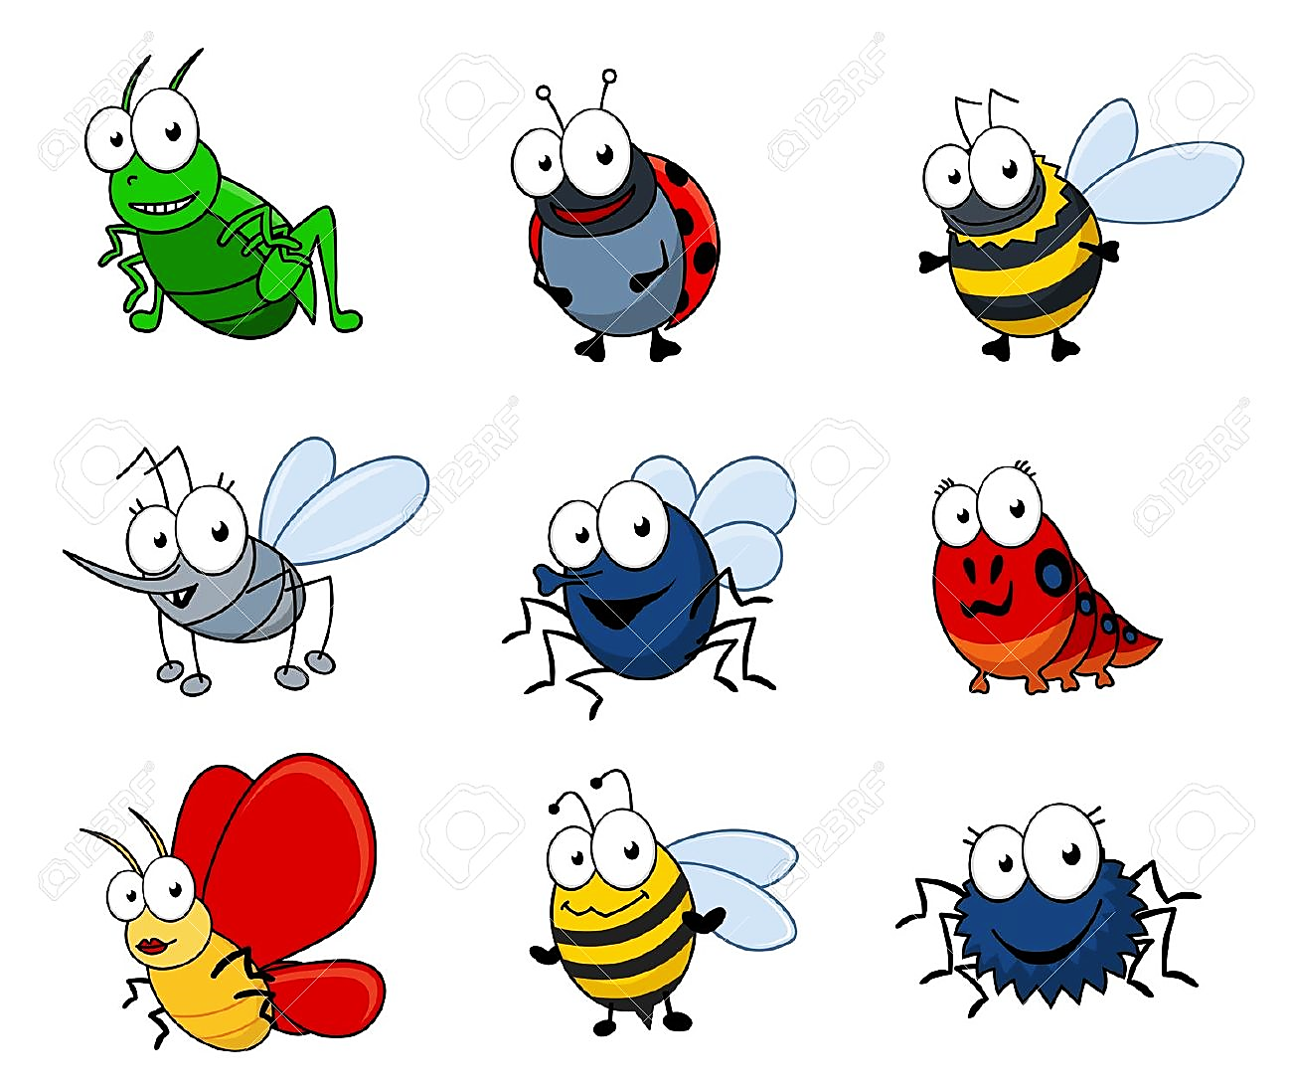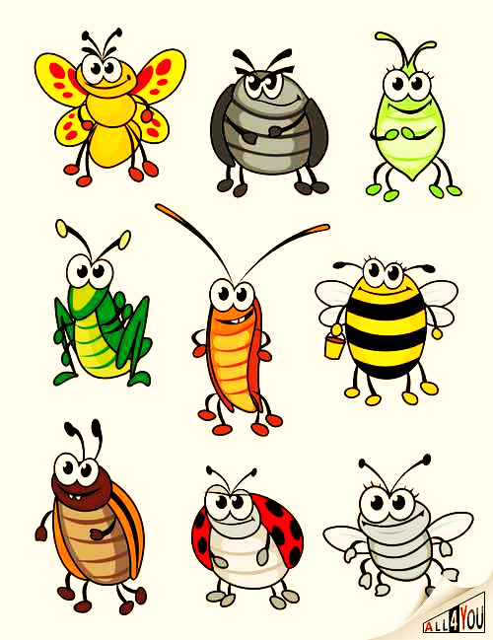

|  |  |
| --- | --- |
| **1 чашка** | **6 чашек** |
| **2 чашки** | **7 чашек** |
| **3 чашки** | **8 чашек** |
| **4 чашки** | **9 чашек** |
| **5 чашек** | **10 чашек** |

