**Present Continuous**

**He She It**

**We You**

**They**

**are**

**is**

**I**

**-ing**

**verb**

**am**

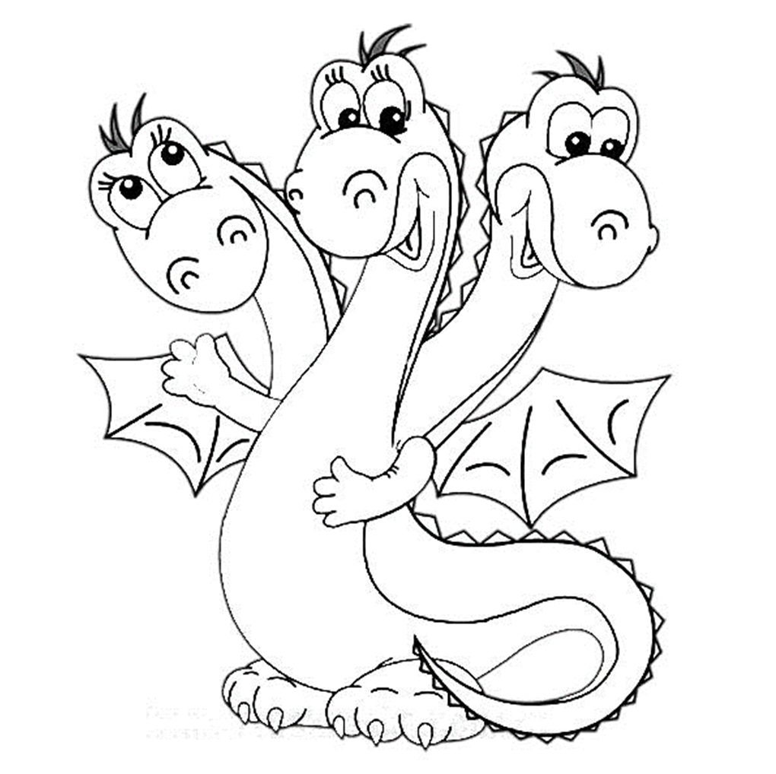

**Present Continuous**

**He She It**

**We You**

**They**

**are**

**is**

**I**

**-ing**

**verb**

**am**



**are**

**am**