Going
to the shop
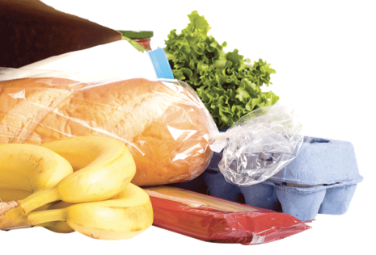
Have you got any ?
I’ve got some .
I haven’t got any .
Here you are.
Yes, sure.

