Игра-викторина
“Britain and the British”
Изучение иностранного языка – это довольно нелёгкое занятие для учащихся, но оно становится интересным и увлекательным, если в него вводить элементы игры и состязательности. Данными характеристиками наиболее полно наделены именно внеклассные мероприятия, которые не имеют строгих требований учебной программы, позволяют более эффективно повысить мотивацию учащихся к изучению иностранного языка и дать почувствовать возможность его практического применения.
Игра-викторина “Britain and the British” для учащихся IV класса позволяет не только систематизировать и обобщить знания по стране изучаемого языка, но и стимулировать учащихся для изучения дополнительного материала по данной теме в рамках подготовительной работы. Основа подачи материала – презентация MS Power Point, которая является средством визуализации информации. Помимо этого учащимся предлагается просмотр фрагмента видеофильма, как источника аутентичных материалов о столице Великобритании. Разнообразие заданий и уровней сложности позволяют создать ситуацию успеха, поддержать интерес участников к игре и обеспечить их активность на протяжении всего мероприятия.
Оснащение: мультимедийная установка, презентация MS Power Point, видеозапись Window on Britain (Oxford English video, extract 08 London), раздаточный материал для команд-участников в виде карточек, в том числе и с названиями команд, и с ответами для жюри (приложение 1).

Ход
внеклассного мероприятия
Good morning! I’m very glad to see you today! How are you? I hope you’ll feel even better up to the end of our session. Its topic is “Britain and the British” (Slide 1). You’ll be given a lot of tasks and asked lots of questions to find out how deep your knowledge of the English language and its native speakers’ life is. I hope you’ll show high brain efficiency.
Game 1. Make up a correct word combination, using all the suggested letter combinations. Remember that this word combination is connected with the topic of our competition (slide 2, the result – slide 3):
THE | UNI | TED | TAI | M | NOR
KIN | OF | GDO | THE | RN | IREL
GRE | AT | BRI | AND | N | AND
Game 2. Watch the video about the capital of The United Kingdom of Great Britain and Northern Ireland and complete the sentences in your cards with numbers (slides 4, 5, the result – slide 6, приложение 2)
1. The Romans built the first bridge over the river Thames in AD _____.
2. The people of London built the second bridge in _______.
3. London has a population of about ____million.
4. London Underground started in ______.
5. Over ____million tourists visit London every year.
6. ____million tourists visit London from abroad.
7. Madame Tussaud brought her exhibition to London in _______.
8. Over _____million people visit Madame Tussaud’s every year.
9. Harrods has ______ departments.
10. Harrods has _____ floors.
11. Harrods has over _____ staff.
12. Harrods has about _____ customers a day.

Game 3. Imagine that you are Londoners. Show us what clothes in your opinion they wear as casual (slides 7, 8). Remember that there are some criteria of a good show:
1. Commenting the show without reading the text, except citing.
2. The absence of mistakes during the report.
3. Describing more than 3 models.
4. Beauty, variety of colours and aesthetics.
5. Accordance to the topic.
6. Usage of different adjectives for describing the models.
7. Something unique.
Accordance to each criterion gives 1 point.
Game 4. Guess what famous place is described and get 2 points, use a picture as a hint and get 1 point. Remember that we speak about famous places in London (slides 9-27).
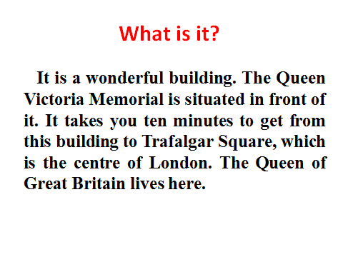 | 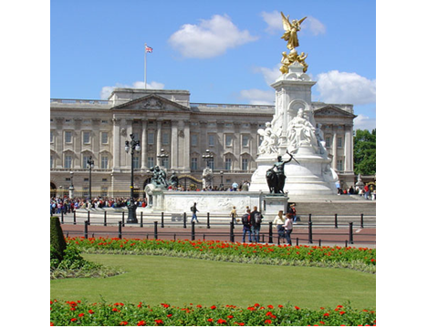 | Buckingham Palace
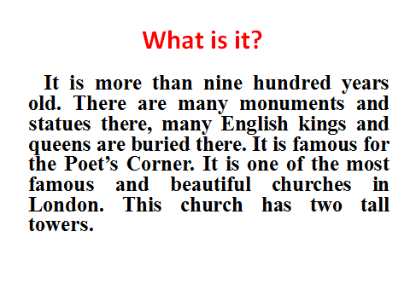 | 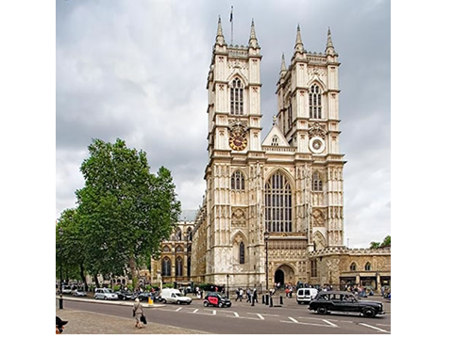 | Westminster Abbey
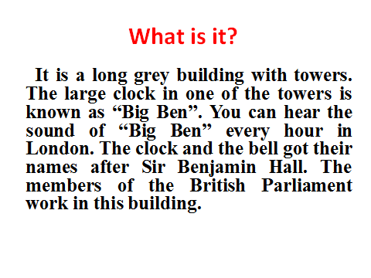 | 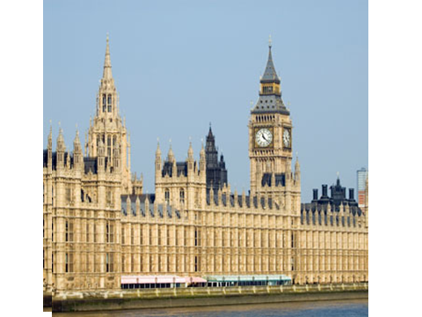 | The Houses of Parliament
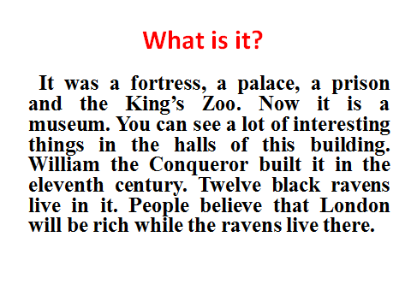 | 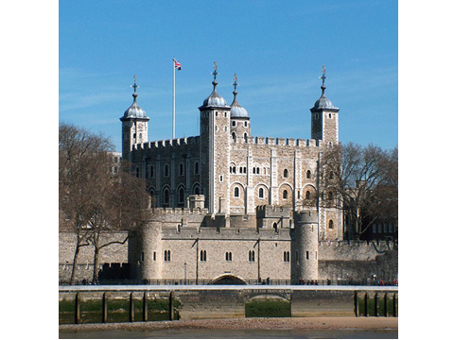 | The Tower of London
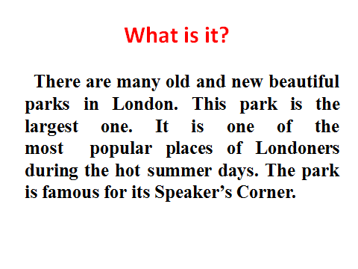 | 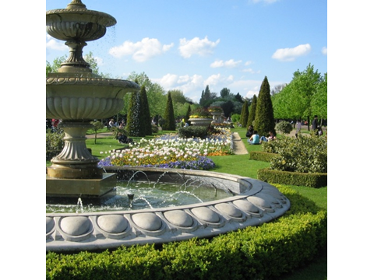 | Hyde Park
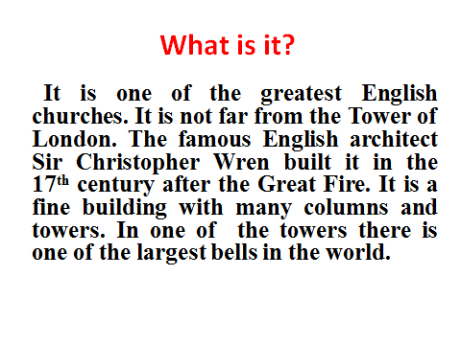 | 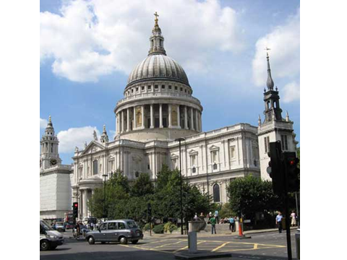 | St. Paul’s Cathedral

Game 5. Correct mistakes (slide 28). Choose a field, read the statement, translate it if you need, find a mistake, make up a correct sentence (slide 29).
1  The UK consists of 3 countries: England, Scotland and Wales. | 2  The two main islands of the UK are Ireland and Wales. | 3  Everyone who was born in Ireland is Scottish.
4  More than 86 million people live in Britain. | 5  The Welsh speak only English. | 6  The flag of the UK is known as the Union Andrew.
7  The ravens are one of the most famous sights at Trafalgar Square. | 8  The symbol of England is a daffodil. | 9  The British Parliament has three houses.
Game 6. Unscramble the sentence. Solve the riddles to get a sentence about the places where the British live (slide 30, the result – slides 31, 32):
 | of |  |  |  | in |  |  |  |  |  | and
Unscramble the word “YMAN” |  | A  definite  article | The one who belongs to Britain is… | An alive person does this |  | Opposite to small | An adjective, which is made from the word “industry” | Big towns | Unscramble the word “KEIL” | The capital of Great Britain |  | The capital of Scotland

Game 7. True/ False. Put up the cards with your teams’ names is you consider the statement to be true (slides 33-42).
1 | In the 17th century the king ordered that sixteen ravens should always live in the Tower of London.
2 | English children ask for “a Penny for the Guy” on the Guy Fawkes Day.
3 | The house of Commons does not have much power.
4 | The members of the House of Lords are elected.
5 | The head of the UK is the Prime Minister.
6 | Admiral Nelson defeated the Spanish at the Battle of Trafalgar in 1805.
7 | Seven streets meet in Piccadilly Circus.
8 | Buckingham Palace is the London home of the Queen.
9 | Big Ben is one of the most famous parks in the world.

Game 8. Choose any picture of a famous British person and say some words about him/her (slide 43). Remember that you can speak about everything you know about the person: the birthplace, the place of living, the family, the famous achievements, the party he/she belongs to, etc. (Slide 44).
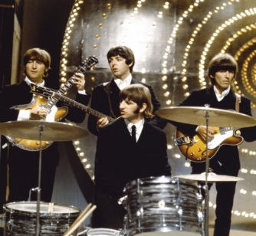 | 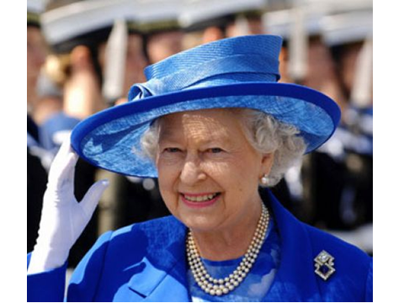 | 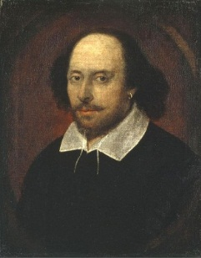 | 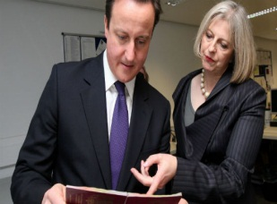

Приложение 1
Games | The Key |  |  |  | The 1st team | The 2nd team
Game 1  Make up a correct word combination. | The United Kingdom of Great Britain and Northern Ireland
Game 2  Complete the sentences in the cards with numbers. | 1. 43, 2. 1774, 3. 7.  4. 1863, 5. 20, 6. 11 .  7. 1802, 8. 2,5, 9. 300  10.7, 11.3000, 12. 35.000
Game 3  “Fashion in London” | According to the criteria of a good show:
 | 1. Commenting the show without reading the text, except citing.
 | 2. The absence of mistakes during the report.
 | 3. Describing more than 3 models.
 | 4. Beauty, variety of colours and aesthetics.
 | 5. Accordance to the topic.
 | 6. Usage of different adjectives for describing the models.
 | 7. Something unique.
 | Total:
Game 4  Guess what famous place is described and get 2 points, use a picture as a hint and get 1 point. | 1. Buckingham Palace,  2. Westminster Abbey,  3.The Houses of Parliament,  4. The Tower of London,  5. Hyde Park,  6. St. Paul’s Cathedral
Game 5  Correct mistakes. | 1. 4 countries,  2. Great Britain and Ireland,  3. Irish,  4. 56 million,  5. English and Welsh,  6. the Union Jack,  7. the Tower of London,  8. a rose,  9. two houses.
Game 6  Unscramble the sentence. | Many of the British live in big industrial cities like London and Edinburgh.
Game 7.  True/ False. Put up the cards with your teams’ names is you consider the statement to be true. | 1 | In the 17th century the king ordered that six ravens should always live in the Tower of London. |  | True
 | 2 | English children ask for “a Penny for the Guy” on Guy Fawkes’ Day. |  | True
 | 3 | The house of Commons does not have much power.
 | 4 | The members of the House of Commons are elected. |  | True
 | 5 | The head of the UK is the Prime Minister.
 | 6 | Admiral Nelson defeated the French at the Battle of Trafalgar in 1805. |  | True
 | 7 | Seven streets meet in Piccadilly Circus.
 | 8 | Buckingham Palace is the London home of the Queen. |  | True
 | 9 | Big Ben is one of the most famous clocks in the world. |  | True
Game 8  Choose any picture of a famous British person and say some words about him/her. | 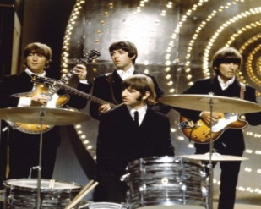The Beatles (1960) |  | 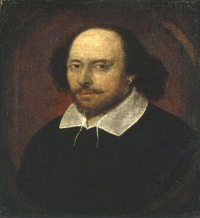 William Shakespeare  (1664-1616)
 | The queen Elisabeth II (was born on 21.04.1926, rules from 1952) |  | British prime ministers Theresa May (2016 - now) and David Cameron (2010 -2016)
Total:
Приложение 2
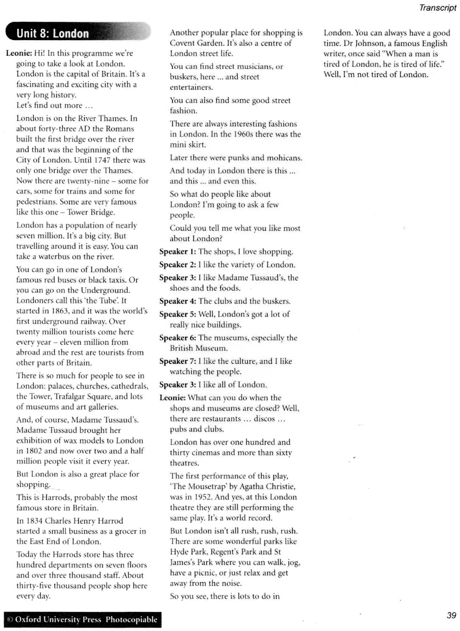
(Transcript)

