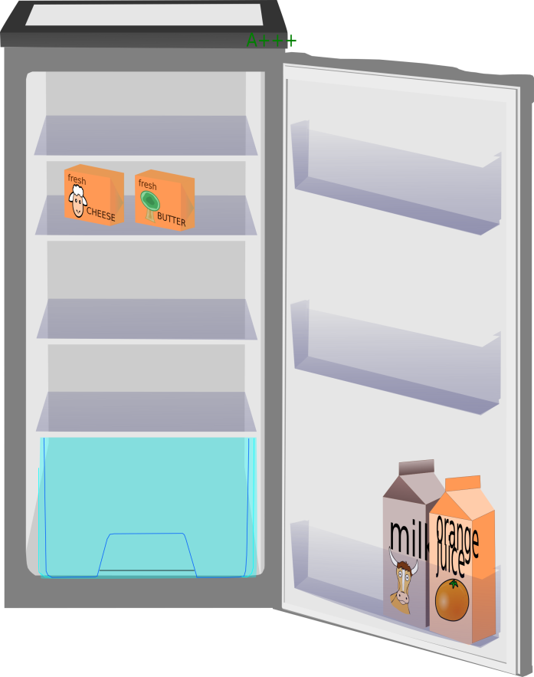

|  |  |
| --- | --- |
| https://openclipart.org/image/2400px/svg_to_png/191196/AlanSpeak-Fridge-open.png | https://openclipart.org/image/2400px/svg_to_png/191196/AlanSpeak-Fridge-open.png |
| https://openclipart.org/image/2400px/svg_to_png/191196/AlanSpeak-Fridge-open.png | https://openclipart.org/image/2400px/svg_to_png/191196/AlanSpeak-Fridge-open.png |